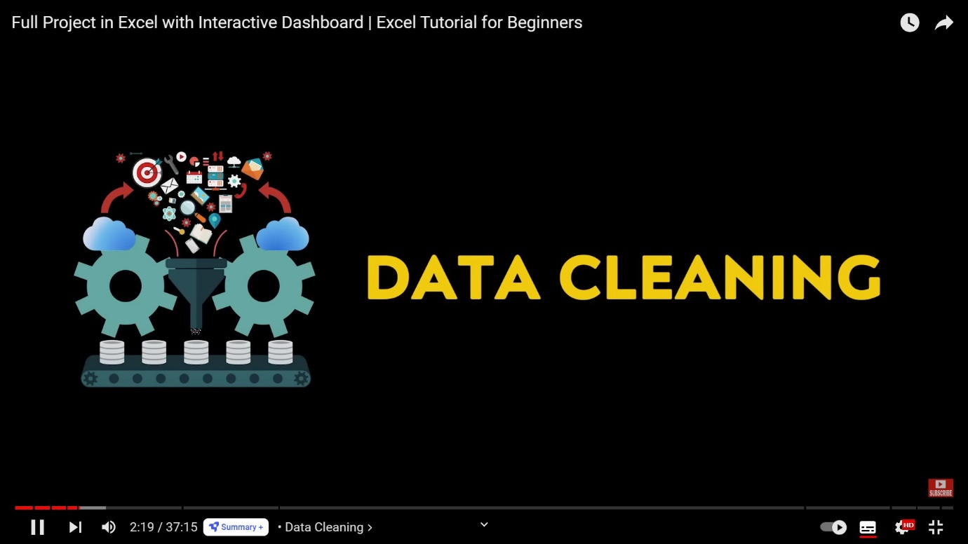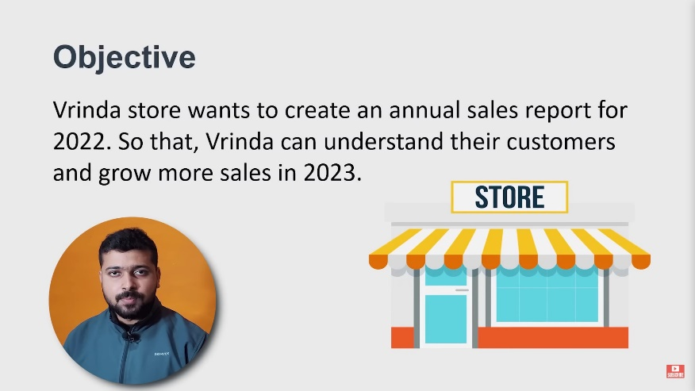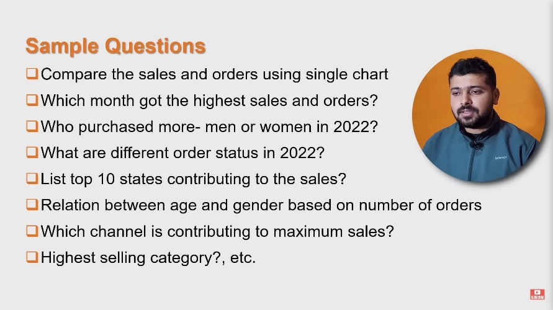Steps Followed

1. Enable Editing
2. Resize all columns by selecting all cells and double clicking on intersection of any 2 columns.
3. **Ctrl+Shift+L** apply filter on all headers
4. Index has 10,000 data points which reflects the number of entries of whole dataset.
5. Order Id column has order numbers and no null values.
6. Customer Id column has numbers from 3 digit to 6 digit and no null entries.
7. In column gender, open the dropdown and see the values.
   * Some values are Men, Women. Others are M and W.
   * Select M from filter and replace all of them by Men.[111 entries]
   * Select W and replace all by Women. [74 entries]
8. Age column contains values from 18 to 78 with no null values.
9. Date column is in short date format with DD-MM-YYYY format ranging from Jan-2022 to Dec-2022 with no null values.
10. Column Status contains 4 different statements:-
    * Delivered
    * Cancelled
    * Refunded
    * Returned

With no null values.

1. Channel contains 9 online shopping site names and others, no null value.
2. SKU[Stock Keeping unit] column is also okay with no null values.
3. Category contains 8 different types of dresses types, with no null values.
4. Size contains ranges form XS to 6 XL, Free and Men. Men is not understandable.
5. Quantity contains ranges from 1 to 5, One and Two, no null values.
   * Select whole column. Ctrl+G. Replace One by 1 [ numeric]. [13 replacements done]
   * Same as indicated above replace two by 2 (numeric) [16 replacements done]
6. Currency is in INR. As all data is of India level only, we can remove the column too.
7. Change AMenount to Amount by pressing F2 and typing correct name in that cell. All data is in numbers from 229 to 3036.
8. Ship-city column is okay. It’s from A to Z many city names. Also we can’t check mis-spell in this column. No null values are there.
9. Same as ship city, many states. No null value.
10. ship-postal-code contains 6 digit numbers. All numbers are there and no null value.
11. Country is India(IN) with no null values. 10,000 entries as stated above.
12. B2B is TRUE and FALSE.
13. Go to view tab. 10th option form left is freeze panes. Open that option and click on freeze top row. **Now Data Cleaning is completed.**
14. 
15. First we are going to look a **relationship between gender and age** as asked in question 6 from image above. But if we directly go for finding a relationship b/w age and gender, excel will see men and women for each age point. That will worsen the processing part.

So what we will do is, we will classify age into 3 groups by making a new column next to age column named **Age group**. Let’s group them into:

|  |  |
| --- | --- |
| Above 50 | Senior |
| 30-50 | Adult |
| Less than 30 | Teenager |

We can apply the formula and drag down in the new age group column. =IF(E2>=50,"Elder",IF(E2>=30,"Adult","Teenager"))

1. As asked in 2nd Question form the image above, we have to **find out the month which got the highest sales and orders**. So we are making a new column after Date column named **Month** **Name** for extracting month from the date.

Formula : =TEXT(G2, "mmm") for writing month in 3 letters, like Dec

Or =TEXT(G2, "mmmm") for writing month in full name.

Then double click on the right bottom corner of cell to auto fill the formula in all cells down.

Highlight the new columns **Month Name** and **Age group** as yellow.

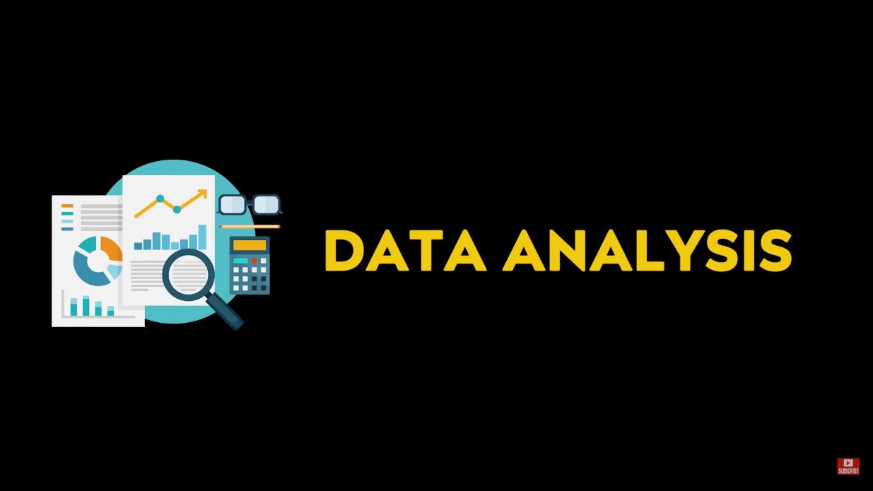

1. Now let’s make a pivot table. Go to Insert in top ribbon, and select pivot table, new worksheet.
2. ***Ques.1*** **Compare the Sales and Orders in one chart**

* 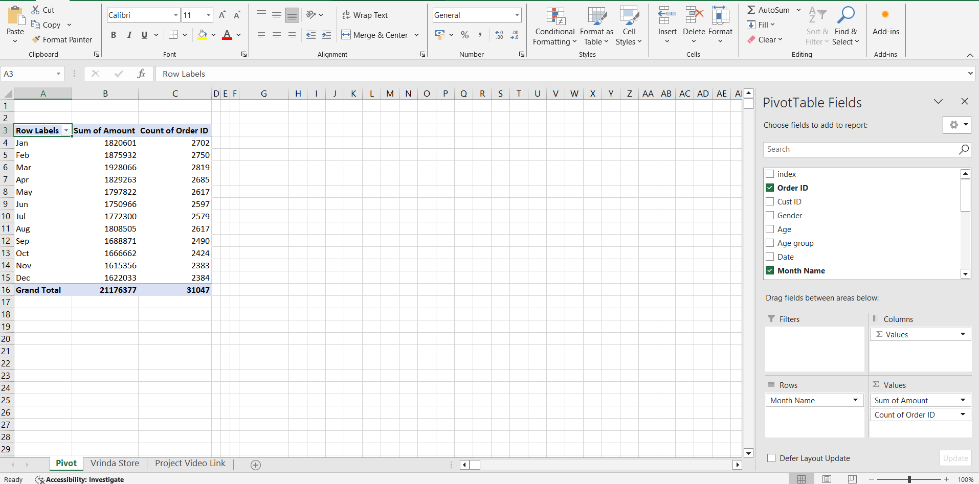Drag Amount (sales) and Order ID to Values box in the bottom right corner and month in the Rows box as shown in the image below.
* Let’s format the data before making a chart. Go to design tab. Open the 2nd option on top ribbon, Grand Totals: It will show 4 options
  + Off for Rows and Columns
  + On for Rows and Columns
  + On for Rows only
  + On for Columns only

Select the option Off for Rows and Columns. This will stop showing the last row of the table(Row-16 in image above, grand total). Similarly other options work.

We’ve done that because we wanted the data from jan to dec only, total is of no use as of now.

* 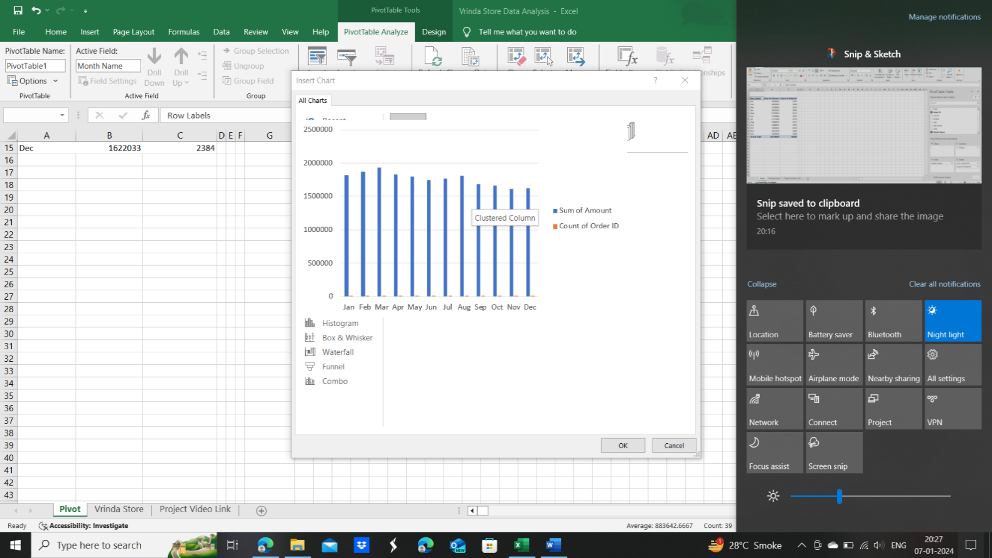Now select the pivot chart and go to tab PivotTable Analyze from ribbons. Select the option PivotChart.
  + First we’ll see clustered column chart which does not looks very good according to our data .

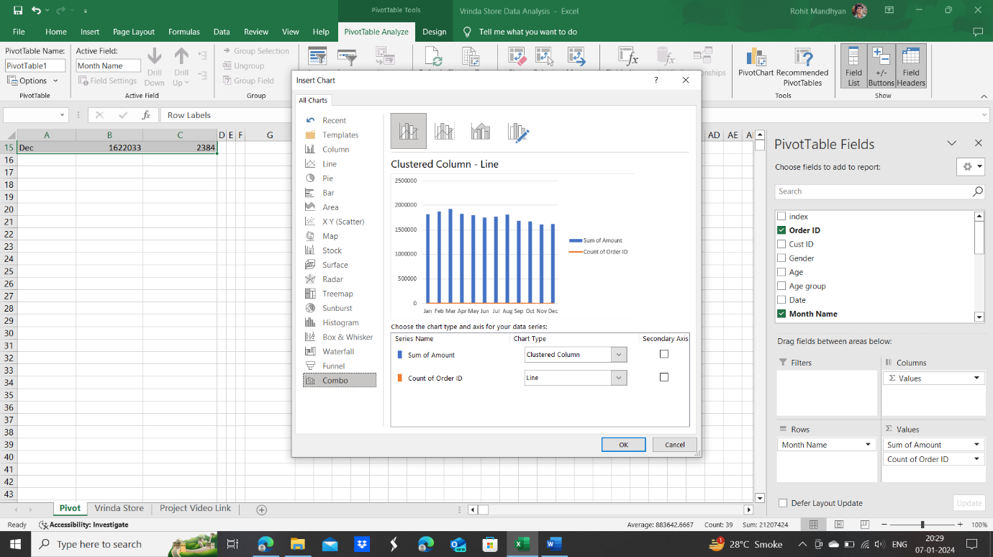

* + We should use a combo type here for the given table and data. We can notice that the orange line of count of order id is supressed to lower side. This happened as the values of sum of Amount is in 6 digits(millions), while the values of Count of Order ID is in 4 digits(thousands). So we need another axis for that. But can you think how to create that ! --?

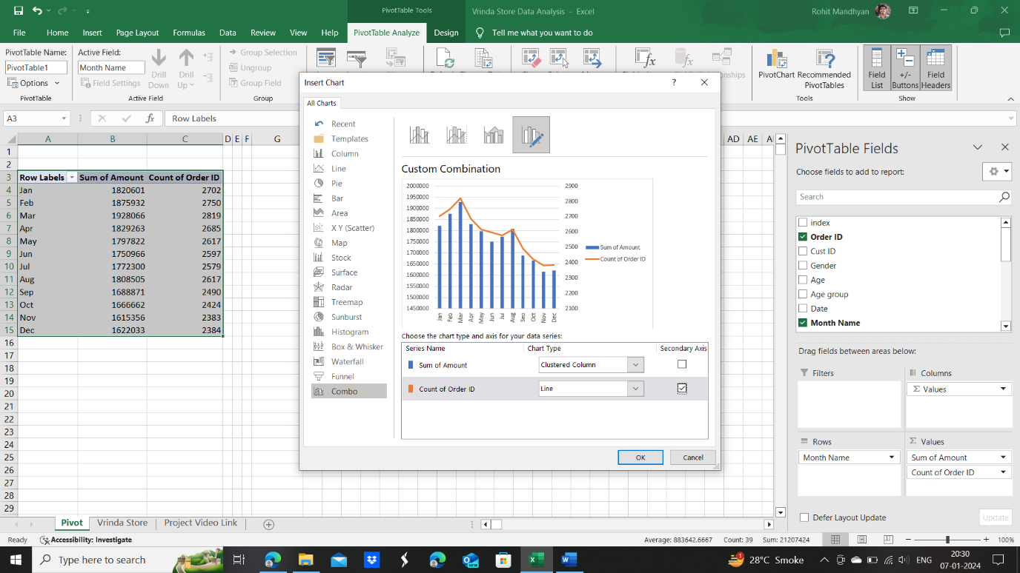

* + Click on secondary axis against line and see the magic. Another axis is created parallel to y-axis and orange line indicating Count of OrderID/Orders is raised up form bottom.
  + Here’s the final result of **Ques.1** & that’s beautiful.

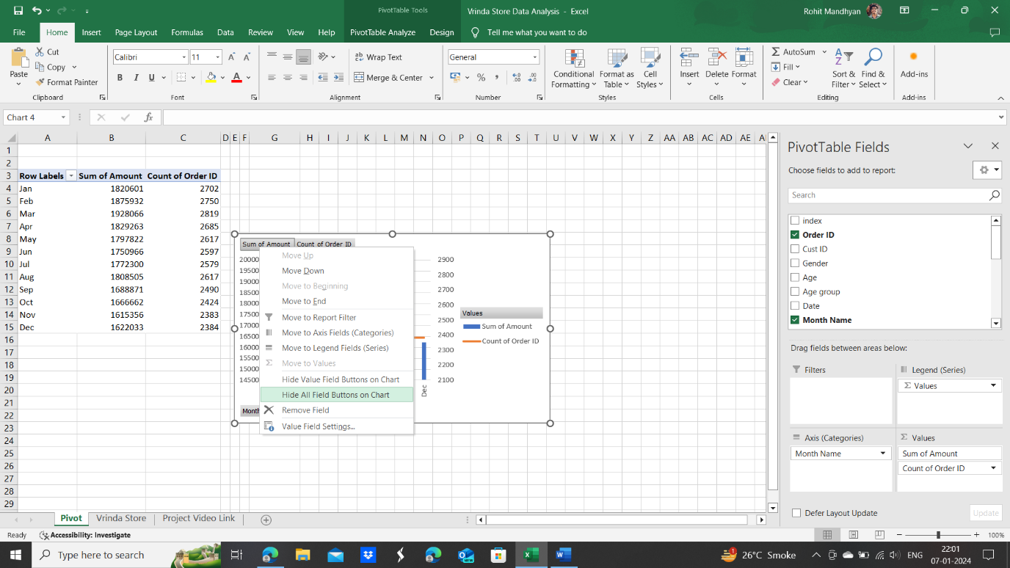

* + Right click on Sum of Amount and you can click on hide value field buttons or hide all field buttons to hide the buttons and get a chart like above.
  + Reformat the chart by adding chart title, moving legend little bit above and increasing the graph area, so that it looks like :
  + We can change it more by clicking on “**+**” button and removing the gridlines so the background looks more clear.
  + Now it comes to changing the numbers from 6 digit to Millions. Let’s see how to do it.

Double click on the numbers menu to open the dialogue box of format chart area. The box will pop up as shown below.

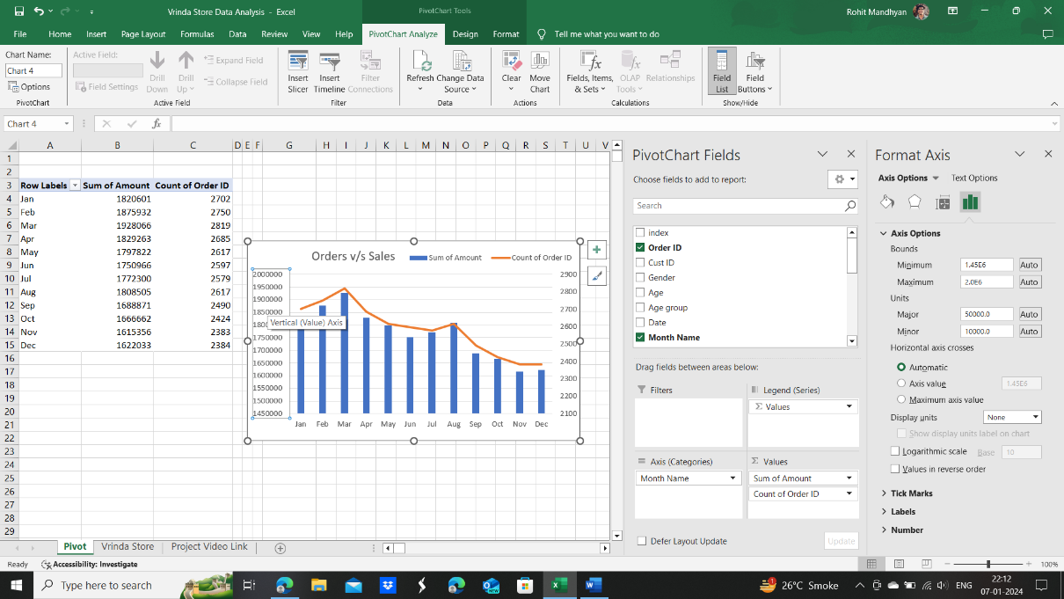

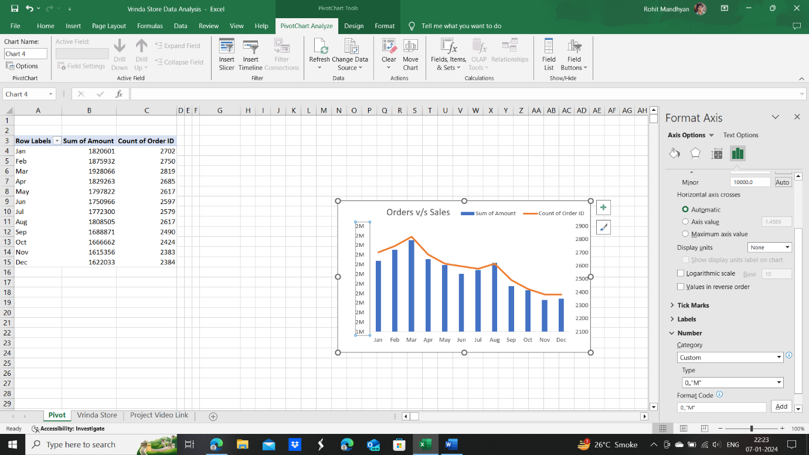

* + Close the pivot table PivotChart Fields and open Number (last option) in Format Axis dialogue box.

Enter there the formula 0,,"M" and click on Add. The numbers will get rounded off single digit with no decimal.

* + To change that to 2 decimal places, change the formula to 0.00,,"M". The final result will look like this and our work is finally done.

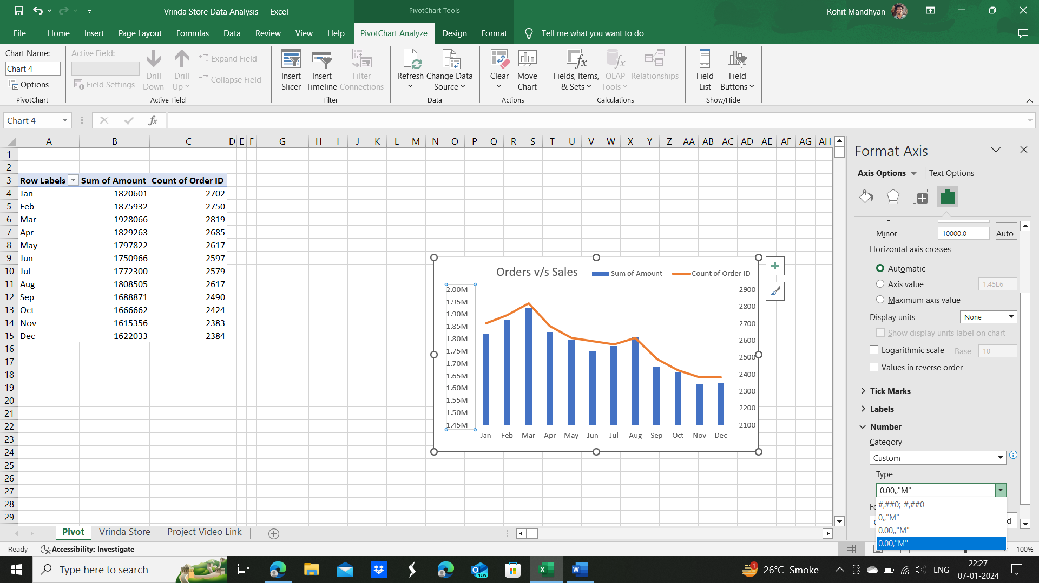

* + More formats are also available as shown.

Done Question-1

* + Make a new tab, Vrinda Store Report-2022. Copy and paste the chart made in question-1 there.
  + Remove gridlines
  + Give title to sheet
  + Make Thick Borders around the title header.
  + Select visible region around and fill background colour with 2nd shade of gray.
  + Dashboard will now look like :

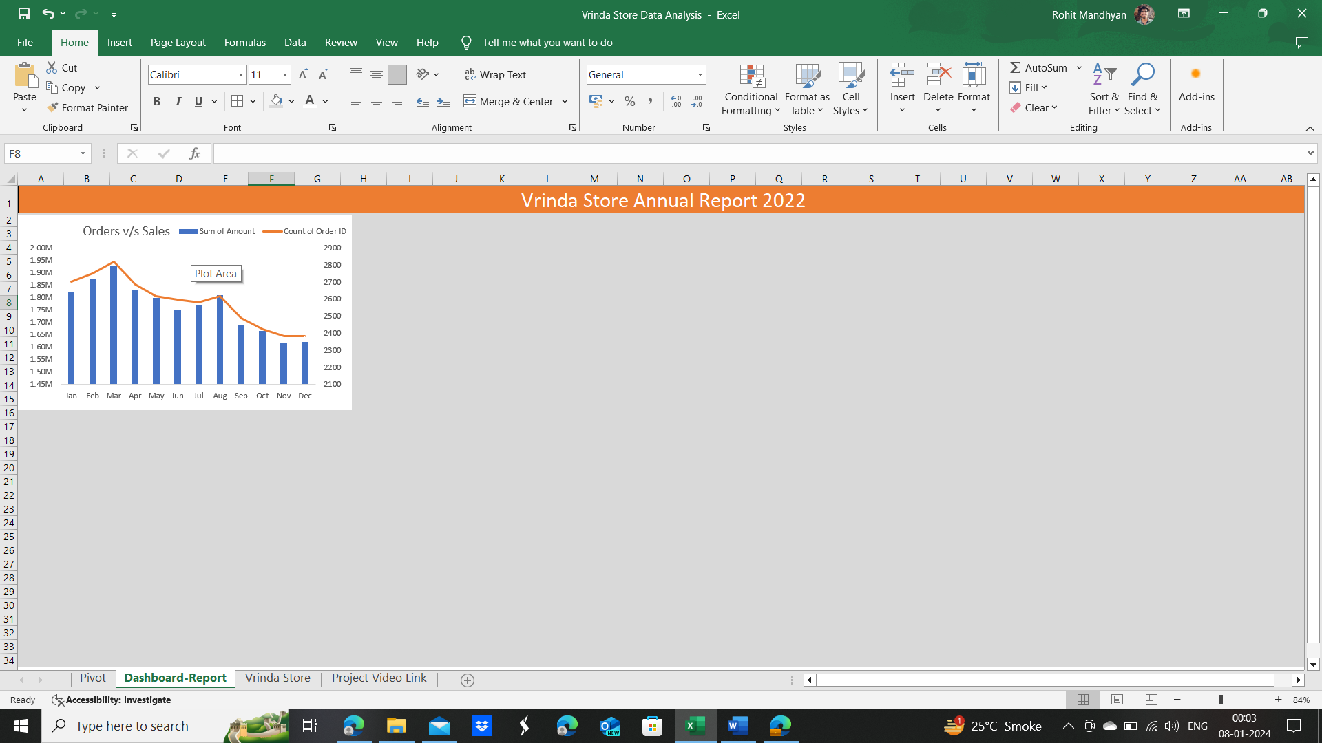

1. ***Ques.2* Which month got the highest sales and orders ?**
   * We can See from the graph drawn that March month got the highest sales of 1928066 INR and 2819 orders (maximum orders).
2. If data changes in future, we just have to click 1st option- dropdown- Refresh All from 5th column in PivotTable Analyze option from ribbon.
3. ***Ques.3*** **Who Purchased more in 2022, men or women ?**

* Make new pivot Table from the cleaned data.
* Include Gender column in rows and Amount column in values form check boxes.
* Remove grandtotal by going in design and clicking Grand Totals- Remove for Rows and Columns
* Go to PivotTable Analyze – Pivotchart
* Select pie chart as we have to find and show the split between 2 groups as percentage or number.
* As pie chart comes, hide all field buttons by right clicking on any button and selecting the option.
* Change chart title to “Sales: Men Vs Women”3
* Click on “**+**” button, turn on data legends and tick data callout in the sub-options.

Now it looks like this :

* Click on called out Men or women option. A Format menu in the ribbon will appear.
  + Open Format menu and do Shape Fill- no Fill
  + Shape Outline- no outline.
* Shift Name of Men and Women inside the Pie chart and make color white and bold.
* Double click on Men or Women and to make the Format Data Label settings appear. In the last row go to number, change category to percentage and set decimal places to 2. The final result is :
* Add this chart to dashboard. **Our answer for ques.3 is as obvious as it should be, i.e Women.**
* The Dashboard now looks like:

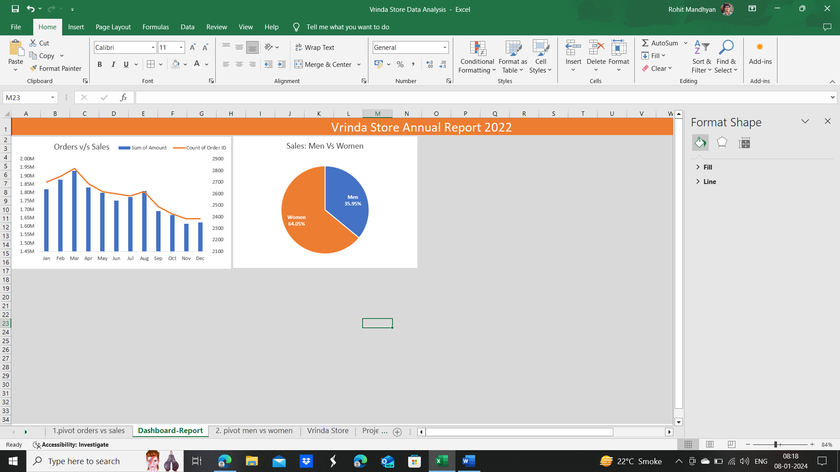

1. ***Ques.4*** **What are the different order status in 2022 ?**

* Make the pivot table with sales in Rows and Order Id( It will become count of order ID automatically when you shift it in Values Box) in Values Section.
* Remove Grand total from Design Tab in ribbon.
* Go to pivot Table analyze and make Pie chart with percentages be following steps in ***Solution-3.***
* Remove Field Buttons
* “**+**” -Tick Data Legends – Outside End
* No Outline and No shape fill from format Tab in Ribbon
* Delete Legends for saving space in chart and finally on dashboard
* Rename the chart Order Status 2022
* Now it looks like :
* We can rotate the pie chart by double clicking on chart area(Orange) and we will get format data series- series options.
* Change the Slicing angle accordingly. 90 degree angle can be chosen.
* Double click on percentage and Format Data-Labels-Label Options. Go to last row numbers-Category. Open the dropdown and select percentage- decimal places 2.
* 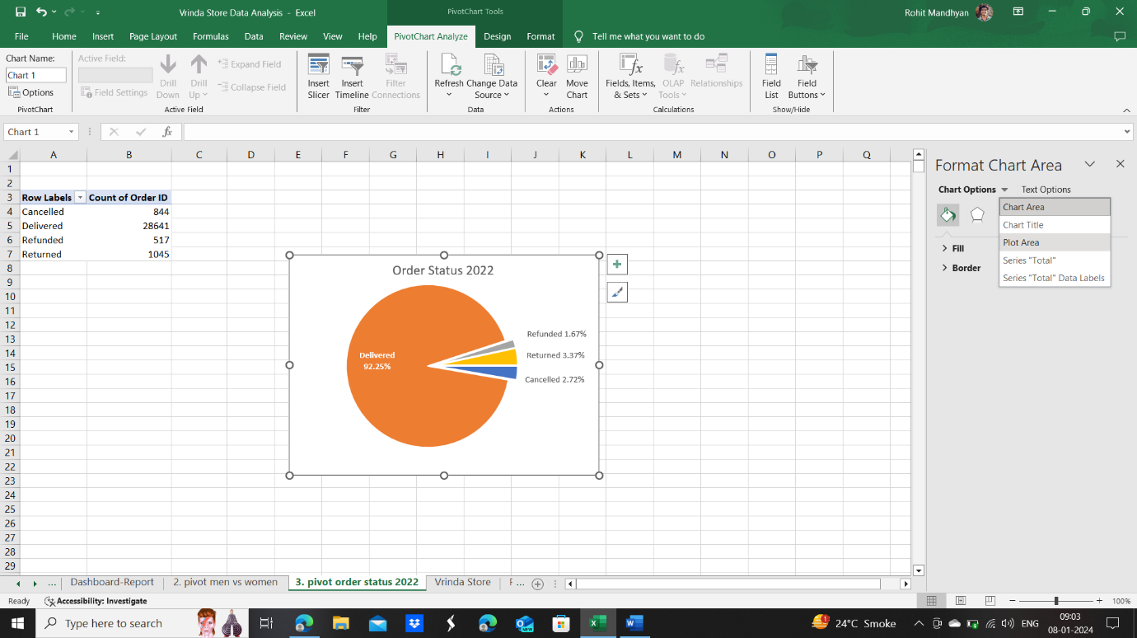Finally, take out the pies just as you take out cake cut outs for eating.
* Arrange the names, align left and make them in 1 horizontal row.
* Increase plot area like as shown in left. Make sure percentages don’t hide out.
* Shift Plot area to left side, rename and increase it a little bit
* The Dashboard and Final Pie Chart looks like :

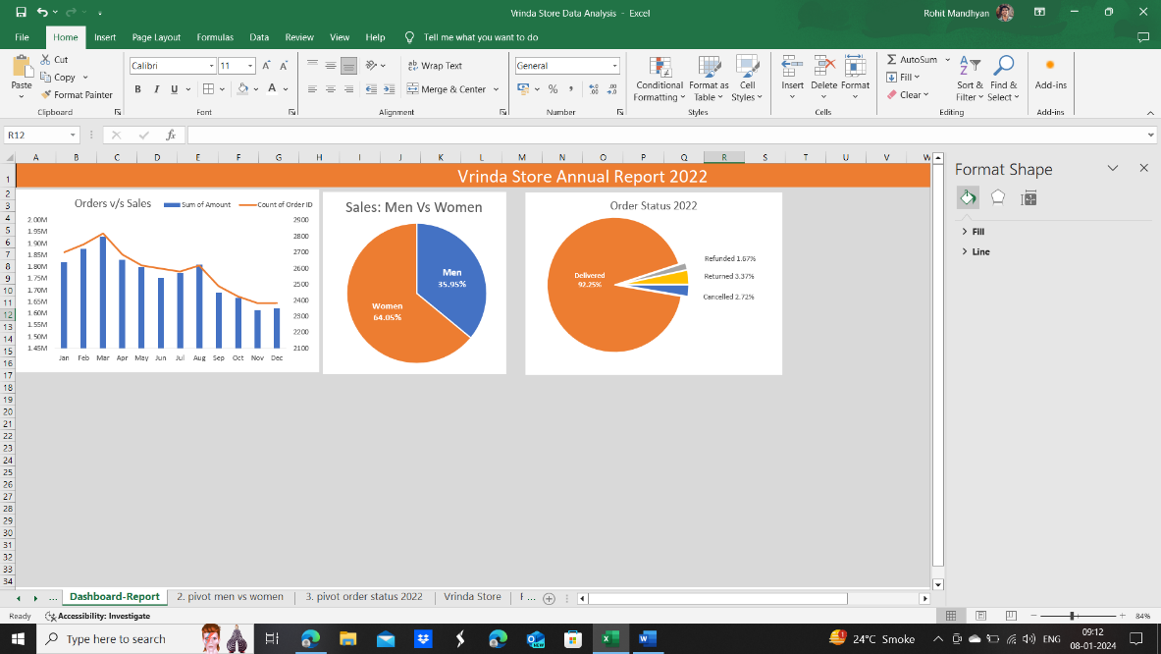

1. ***Ques.5* List the top 10 states contributing to the sales**

* Make New worksheet for pivot table.
* We would need the top 10 states dynamic because they would be different in each month. January would be having different top 10 states compared to February and so on.
* And if we club two or more months, then also the top-10 states can be different.
* So let’s go with the method of clubbing the sales[Amount] of whole year 2022 and then ranking the states.
* Do it like given in image below- right click in 2nd column and the options box will open up.
* 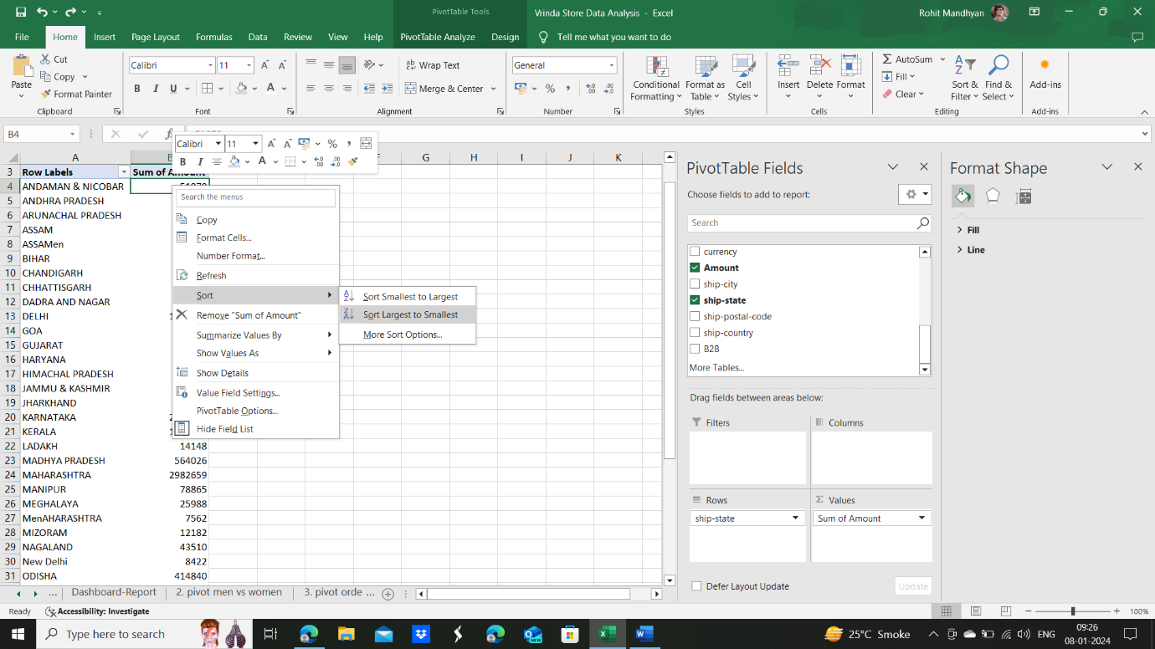 Sort form largest to smallest
* 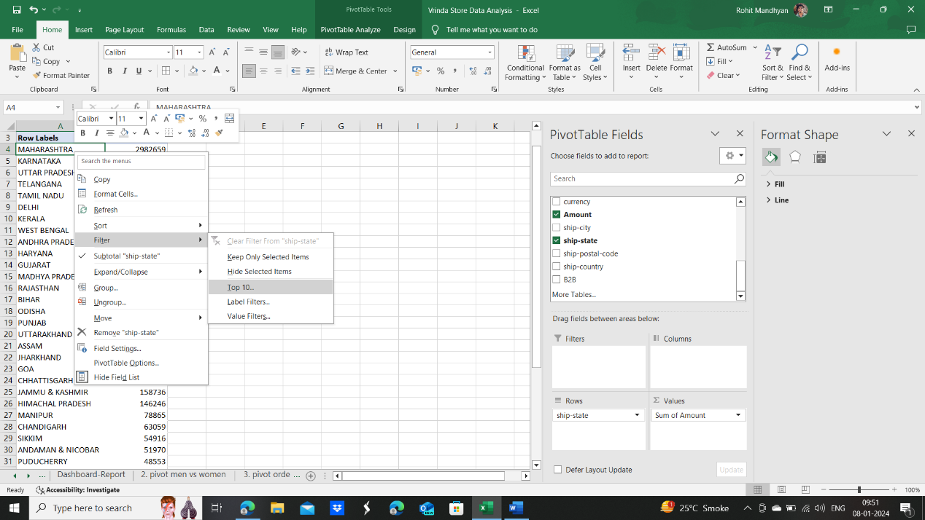Right click on the first column then and filter out top 10 values.

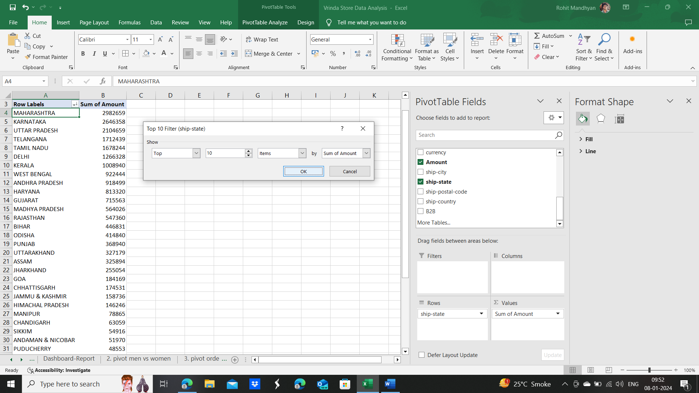

* After selecting filter top10 option a dialogue box will come as shown. Change the number if wanted. Let’s keep it top 10 only.
* Remove grand totals by going on design tab.
* 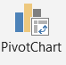Now let’s make a pivot chart. Make a horizontal bar this time. Select Data- PivotTable Analyze- PivotChart , hide all field buttons and remove Legend.
* Click “**+**” and remove gridlines.
* Change chart name to 2022 Sales: top 10 states.
* Change Y-axis values to 2 decimal places and X-axis values to single decimal places by double clicking and going to numbers option like previous. Use 0.00,,"M" for Y-axis and 0.0,,"M" for X-axis values.
* Finally it looks like this :

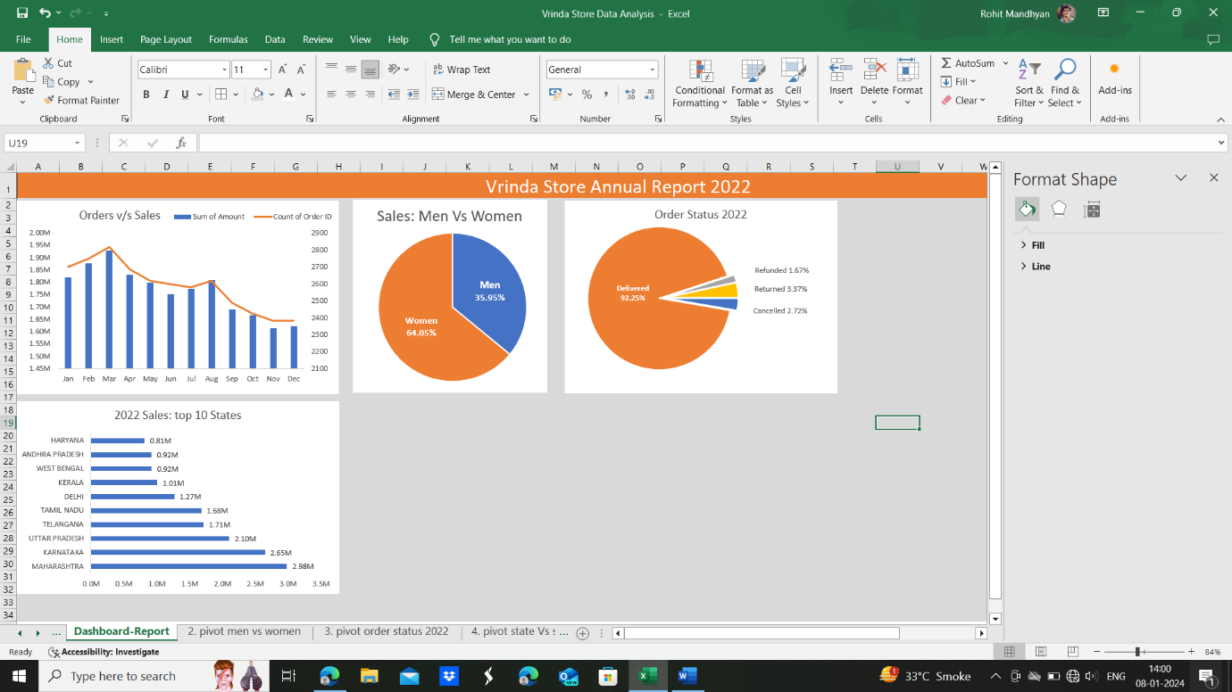

1. ***Ques.6* Relation between age and gender based on number of orders**

* Insert new pivot table from raw data
* 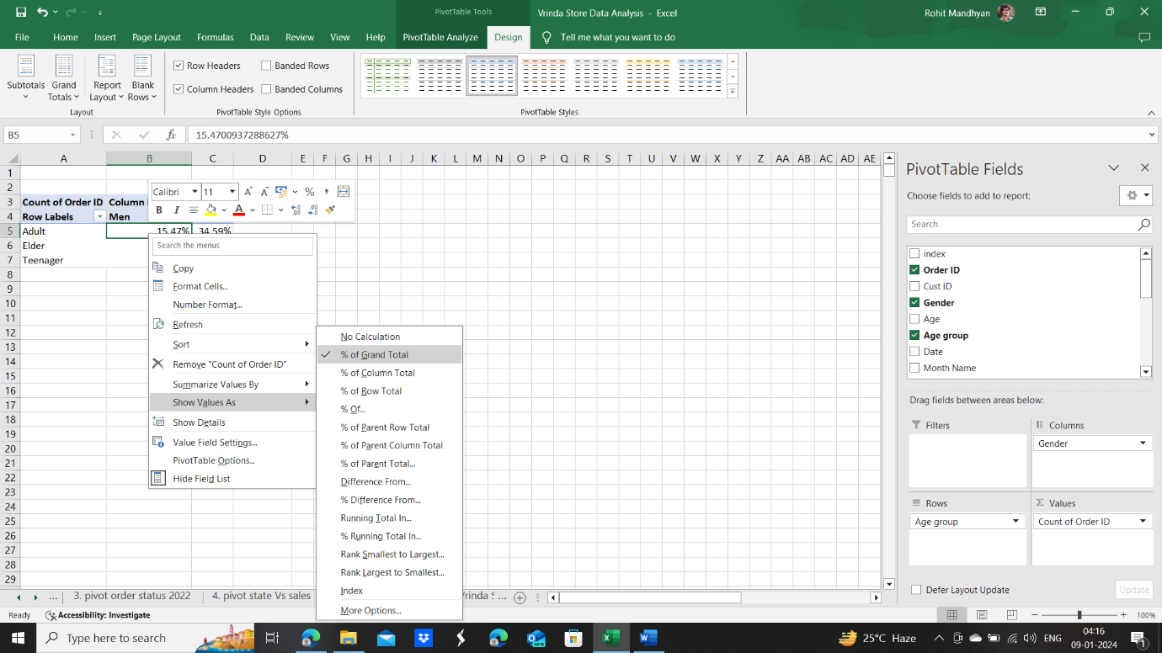Put Gender in columns, age group in rows and OrderID (count) in values section.
* Remove grand totals from rows and columns by going in Design Tab
* Right click on any number in Men or Women’s section and select as given in image beside:

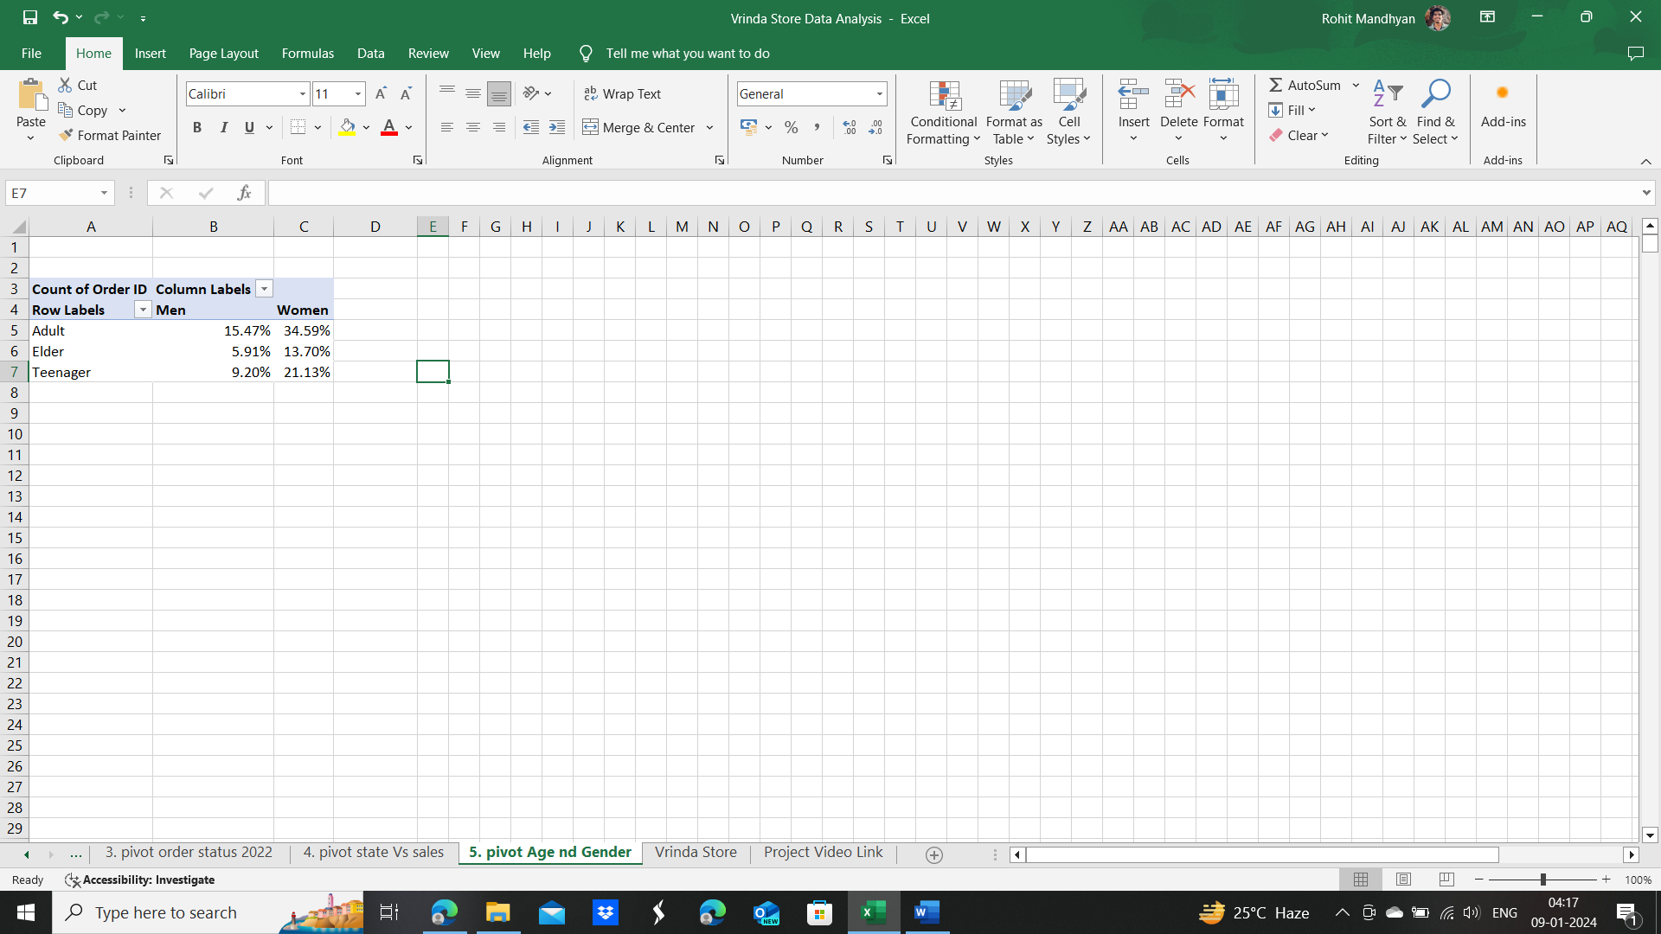

* We can see that 15.47+35.49+5.91+13.70+9.20+21.13 =100% which means it calculates the percentage out of all orders. We could also have thought like x% for Adult Men and (100-x)% for Adult Women, thinking in that direction.
* So Adult Women(35.49%) are the major customers of Vrinda Store.
* Coming on to chart making. Select data, go to PivotTable Analyze and select clustered column chart
* Hide all field buttons, add chart title and data labels plus remove gridlines by clicking on “**+**”. Name the chart 2022 Orders : Gender Vs Age
* Shift the legend on top and spread width so that both names come in line.
* Finally it looks like :

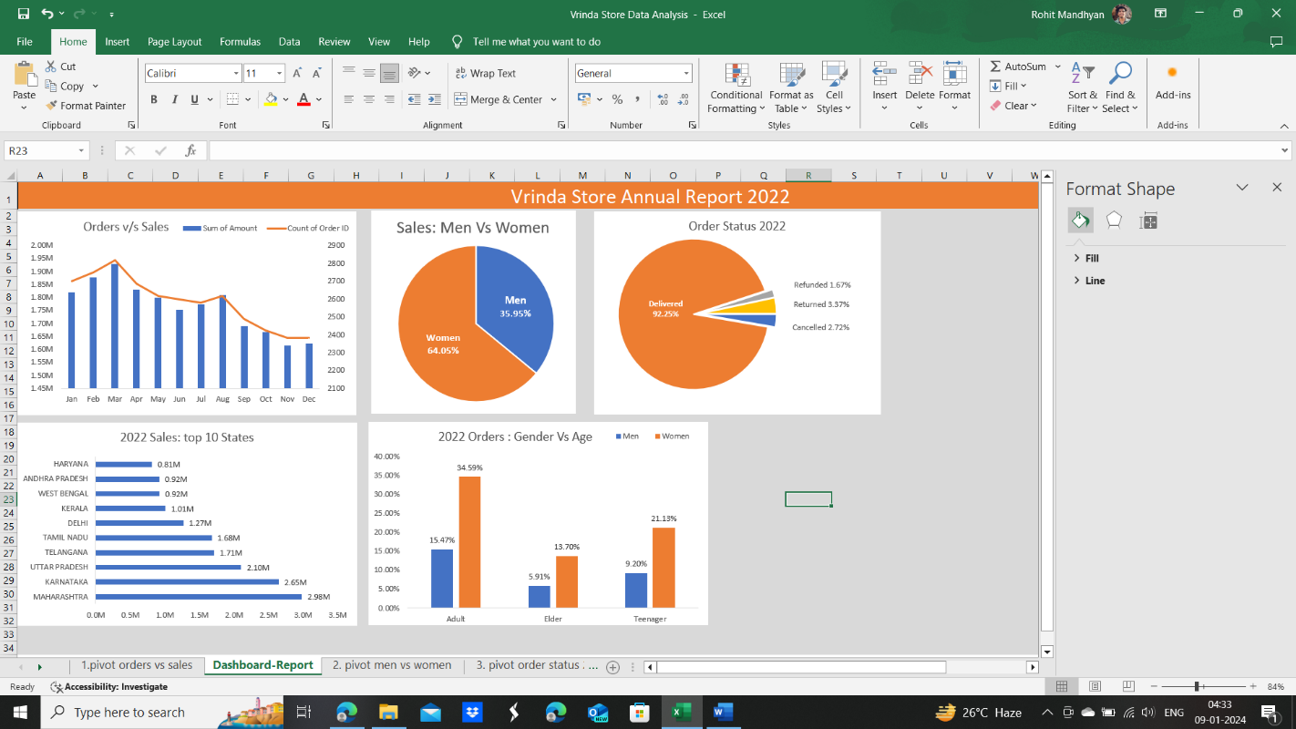

**End Ques.6**

1. 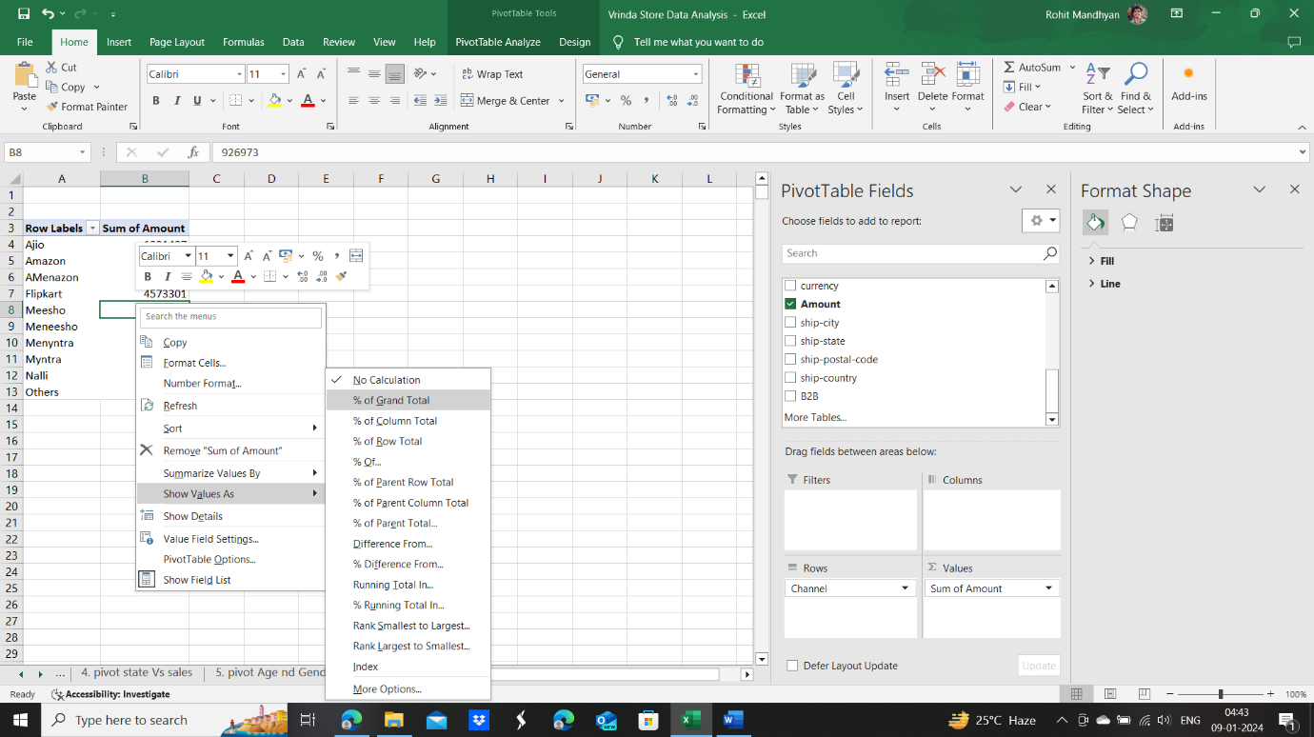***Ques.7* Which channel is contributing to maximum sales?**

* Insert new pivot table from raw data
* Insert channels in rows and amount in values.
* Remove grand total for rows and columns by going in Design Tab
* Take values as percentage of grand Total :
* Make a pie chart
* Finally the Dashboard look like

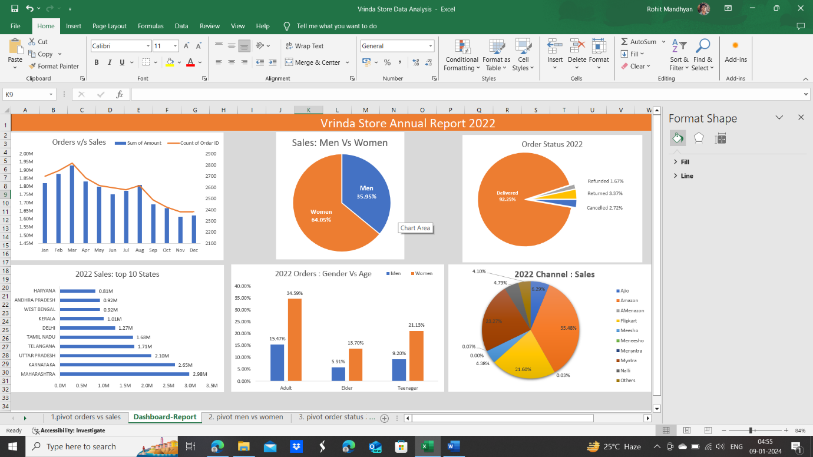

**End Ques.7**

1. 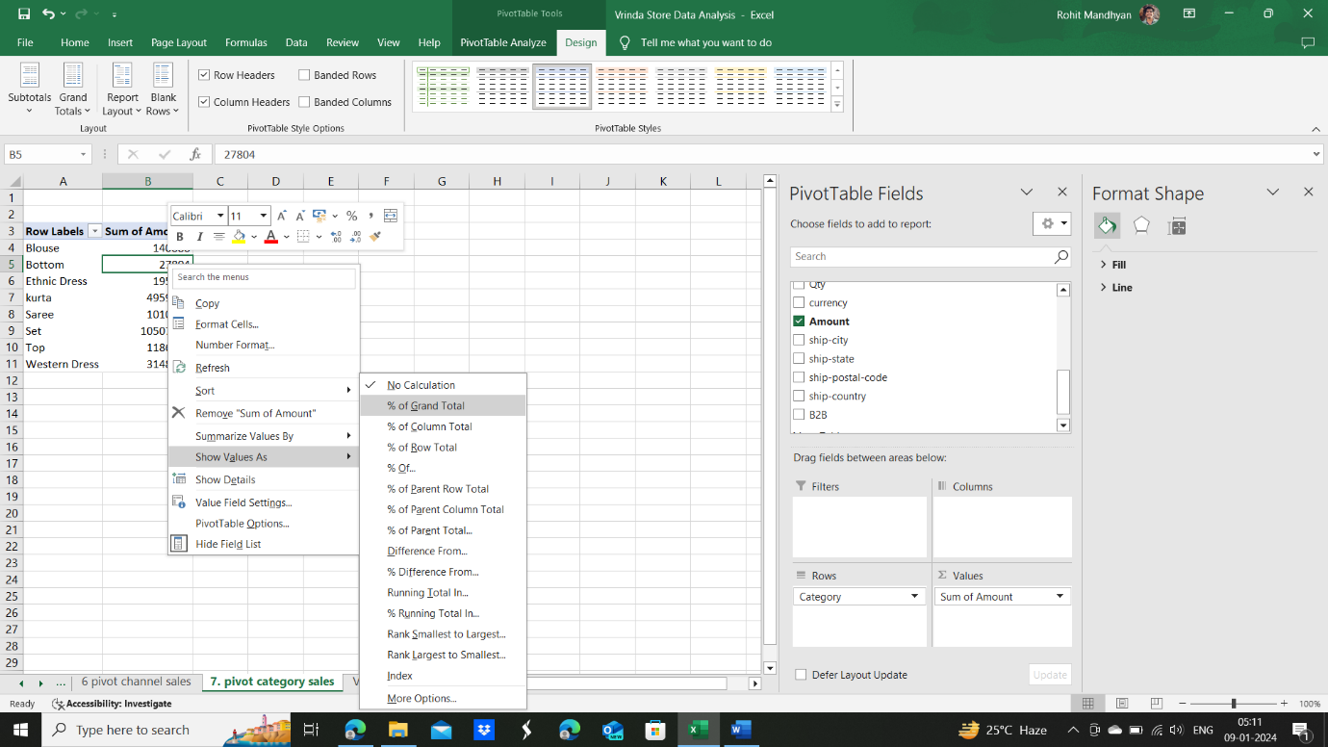***Ques.8* Highest Selling category**

* Insert new pivot table from raw data
* Put category in row and Amount(sum) in values.
* Summarize values into % of grand total as shown in the image left:
* Turn off grand total from rows and columns- Design Tab
  + Make and arrange the Bar graph, remove legend, change title to 2022 category : Sales and remove gridlines.
  + Ita Finally looks like :

And the Dashboard looks like:

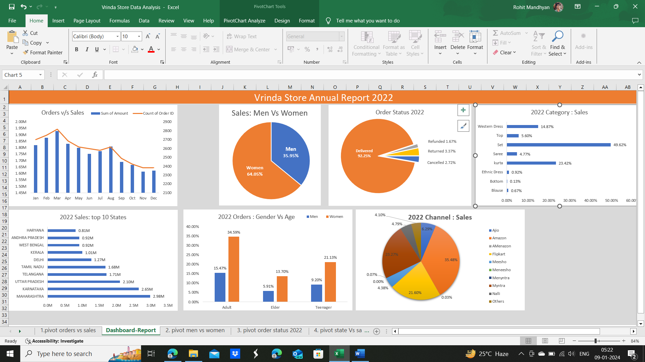

1. Now think off that why we’ve came till here. Why are we making a dashboard.

The answer is, that it **can be made dynamic if the graphs are *linked to a pivot table***.

Dynamic here means you can filter the graphs according to need.

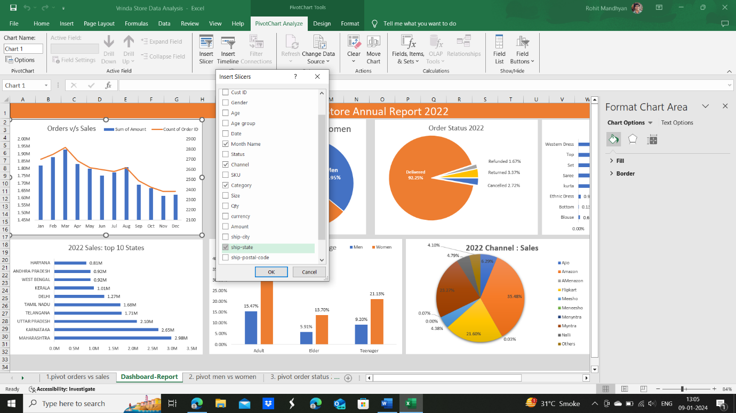

Let’s see how. The method is to add Slicer in Dashboard.

* Click on any chart in dashboard. Open PivotTable Analyze and click Insert Slicer option from the ribbon menu.
* Check these 4 options as given in image:
* Click Ok
* Now if you click on any filter option say January, only the first graph changes. So what should we do to connect all graphs to our filter option. Means, if I select 1 filter option, all the 7 created graphs should change accordingly.
* 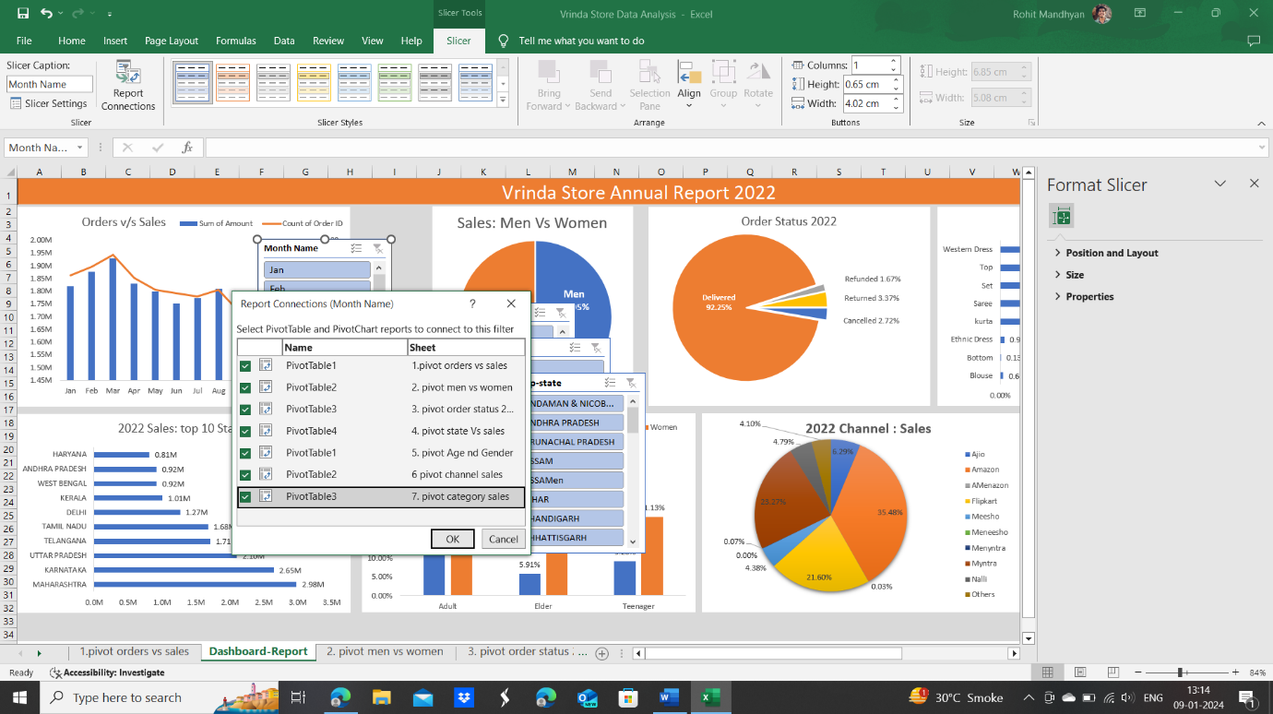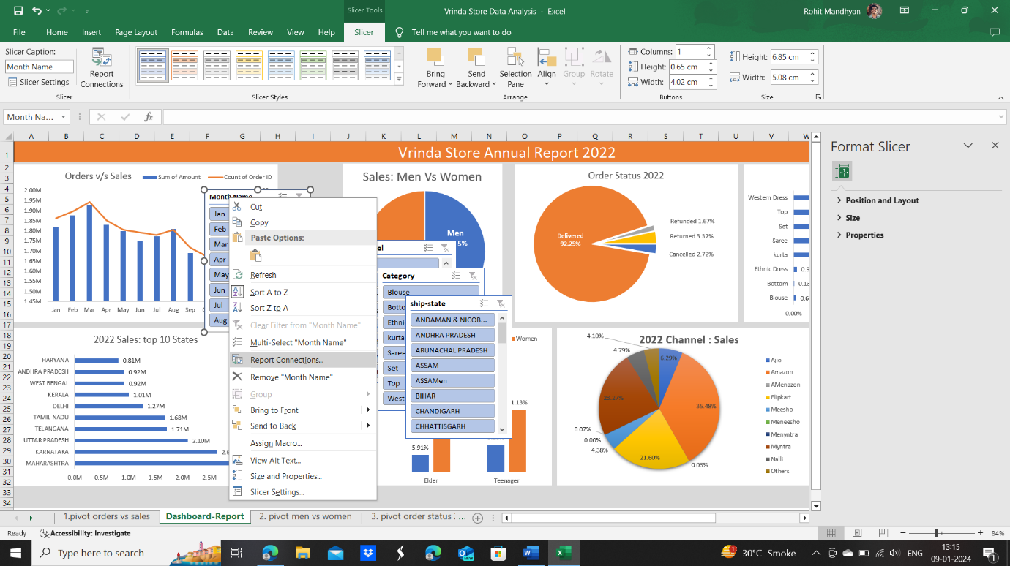The next step is to right click on the Month slicer and select report connections.
* Then select all the 7 pivot tables to the slicer as shown in the images on left and right.
* Repeat the above 2 steps for all the 4 slicers, and arrange them on the left size of the dashboard by resizing them to fit in the height of the page.
* Click on the zoom number on the right-most bottom corner of the page and set the number to custom-78% and make the background on same grey colour as before till the end cell (36,AE). Also increase the title name cell background length.
* **You can click on clear filter option on top right of slicer if want to return back on original graphs.**
* Finally our dashboard looks like:

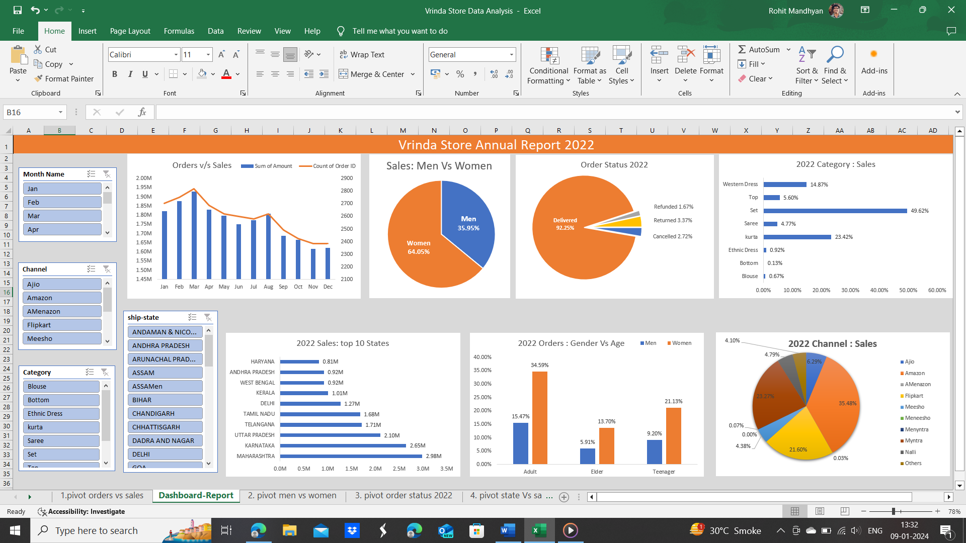

**End Dashboard**



1. Till now we’ve worked on the report part and completed it successfully. Now let’s talk about insights, what questions were given to us in the start

* Most sales occur in march of about INR 1.93 M
* Women make the most sales around 64.05% from Vrinda Store in 2022.
* Delivered orders correspond to 92.25%
* Set is the mostly sold item corresponding to 49.62%
* Most sales is made in Maharashtra of around INR 2.98 M
* Gender Vs age buyers are like

|  |  |  |
| --- | --- | --- |
| Buyer group/Gender | Men | Women |
| Adult | 15.47% | 34.59% |
| Elder | 5.91% | 13.70% |
| Teenager | 9.20% | 21.13% |

Which is a subset of our previous result as Adult Women make buying of 34.59% clothes from grand total sales.

* Amazon is the channel partner generating highest sales of 35.48%, second is Myntra with 23.27% sales and 3rd is Flipkart with 21.60% sales.



You can give sample insights to the customer(Vrinda stores for a Data Analyst) which are indicated in point 37.

Also add a final conclusion.

* Target **women** customers of age group **(30-49 yrs)** living in **Maharashtra, Karnataka, UP, Telangana, Tamil Nadu and Delhi** (Top-6 sales producing states) by showing ads/offers/coupons available on **Amazon, Myntra and Flipkart**.

Sample insights and conclusion given by Sir in the Video are:

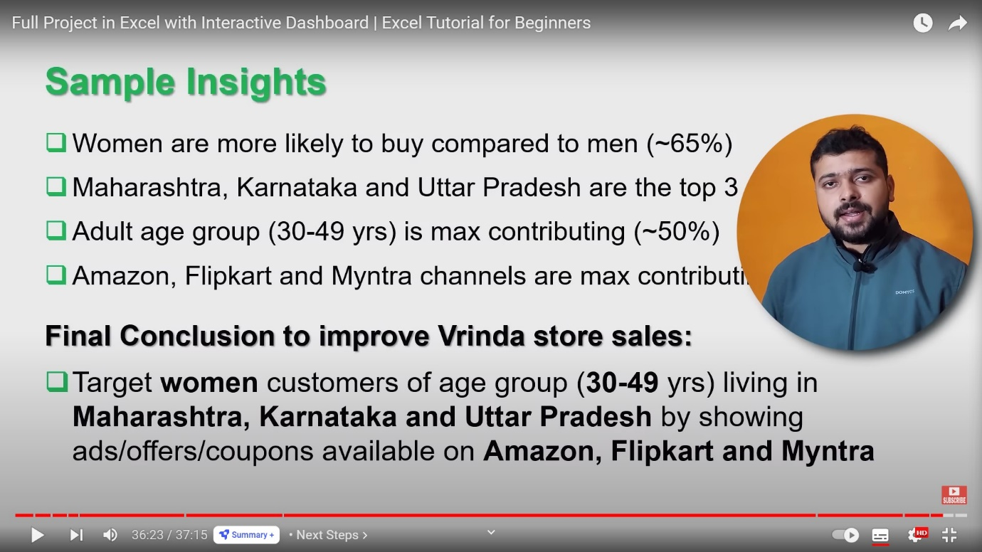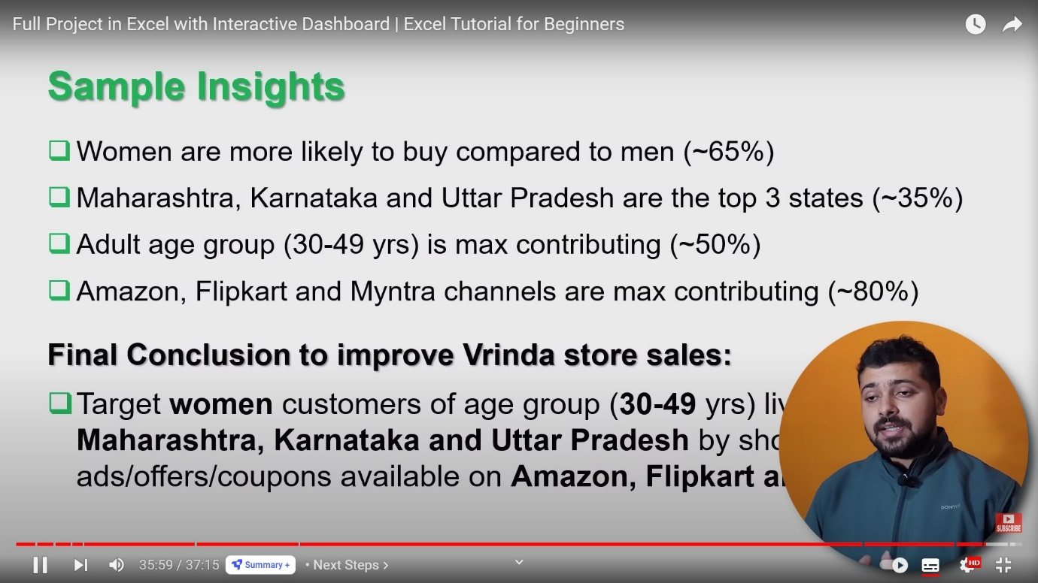

I would like to thank sir for providing such a great tutorial session on Dashboard making with very good explanation and technicalities by using excel. I’ve personally learned a lot from the video and look forward to work with you in future.

Link of tutorial video :

(397) Full Project in Excel with Interactive Dashboard | Excel Tutorial for Beginners - YouTube <https://www.youtube.com/watch?v=gTK5rNhWJyA>

I’ve developed this document while completing the dashboarding excel project and it took me 4 days [6-9 Jan 2024] to complete it, with my ongoing semester in college.

You’ll also find this document and the excel file at my github

Excel-Projects/dashboardVrindaSales at main · rohitmandhyan07/Excel-Projects (github.com) :

<https://github.com/rohitmandhyan07/Excel-Projects/tree/main/dashboardVrindaSales>

Thankful to all the viewers of this document

Rohit Mandhyan

4th year undergraduate

Department of Energy Science and Engineering

IIT Bombay

LinkedIn : <https://www.linkedin.com/in/rohit-mandhyan-9730b41b9/>